Project 2:

Use AWS Cloudwatch Event rule to schedule the Lambda function. Create a Start fn (run at 9 am) and a stop fn (run at 10 am).

Sample start and stop time

Stop -12:10pm

Start-12:15pm

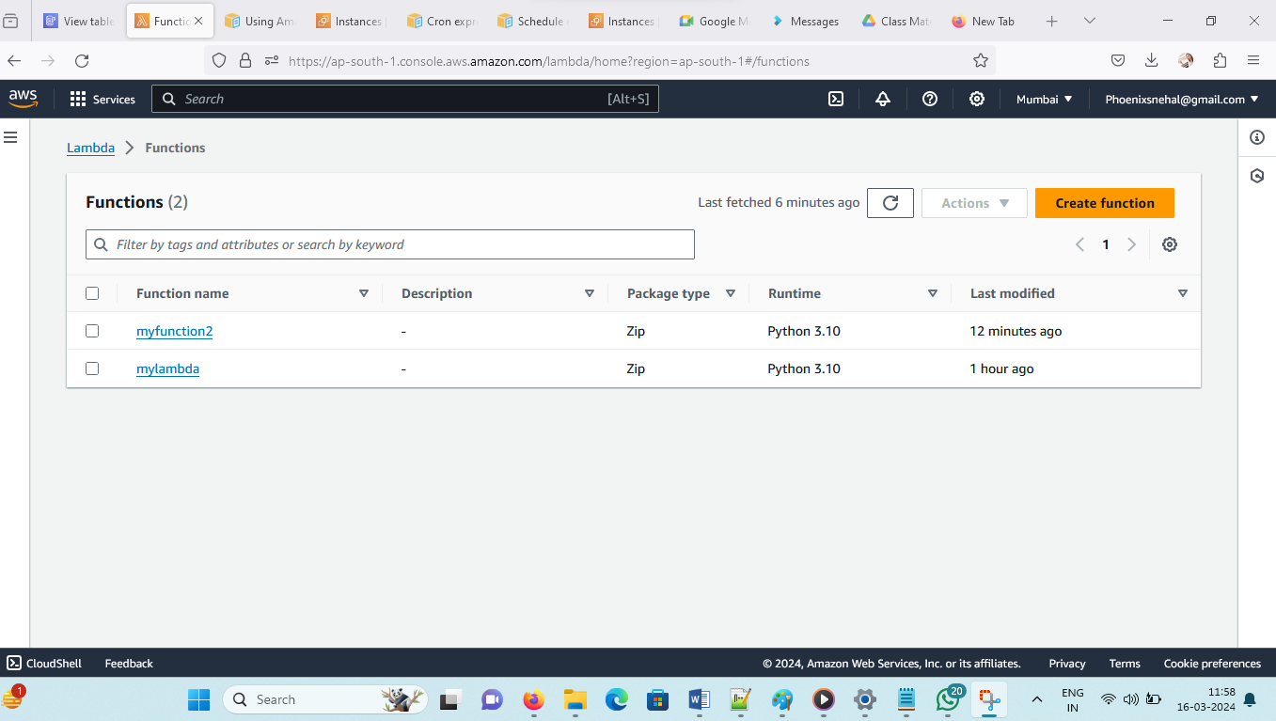

Currently 2 instances are running-

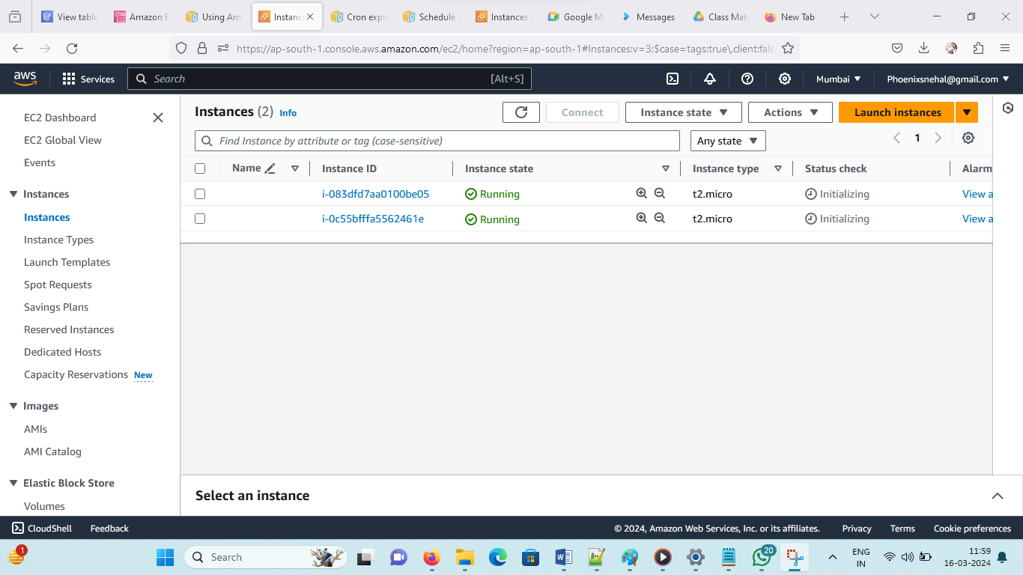

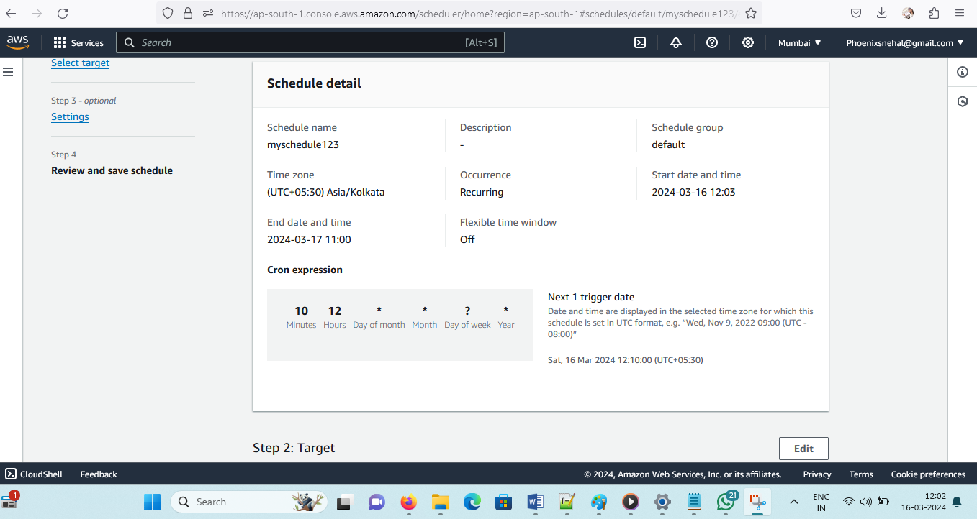

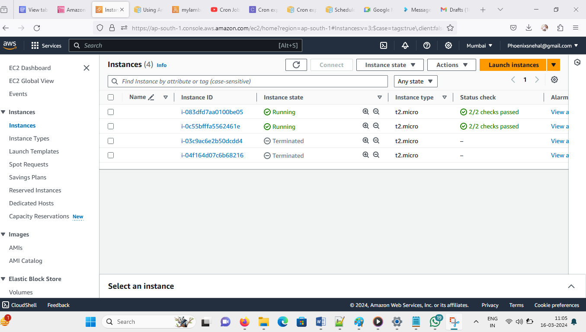

12:10 stop-

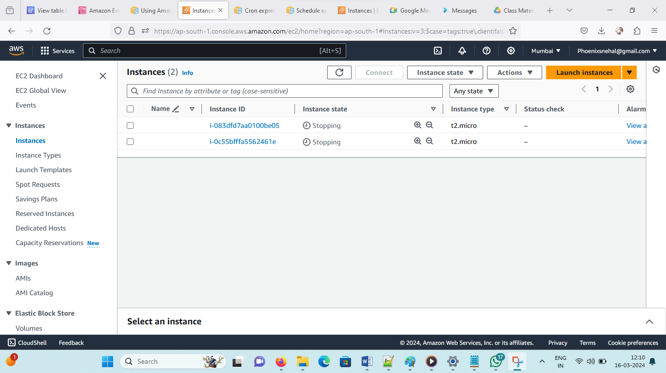

12:15 start

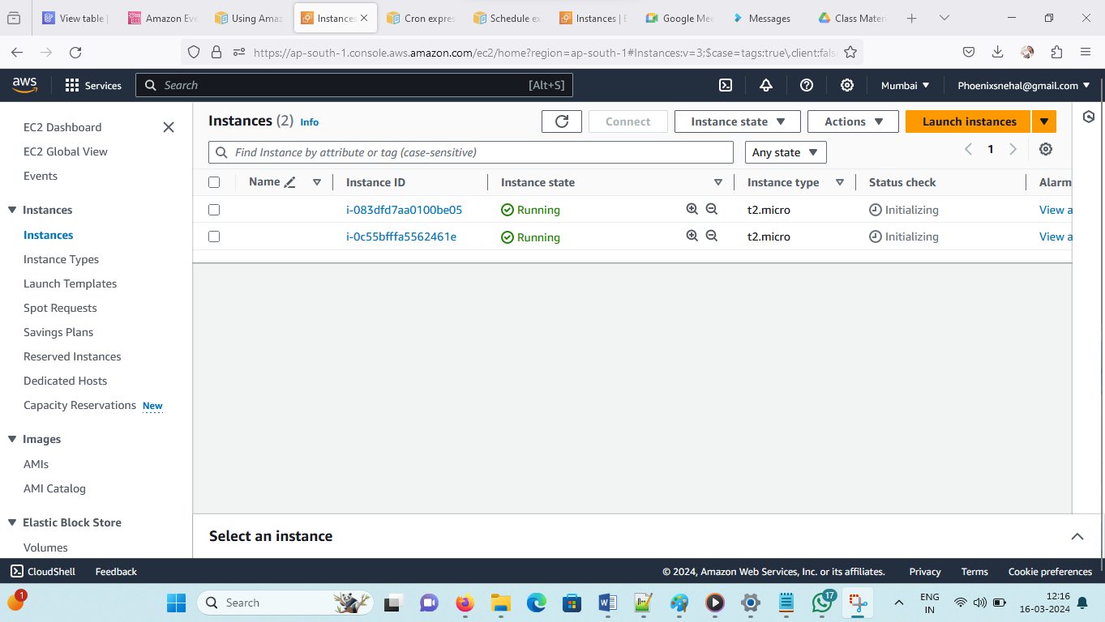

Steps to follow –

1. Create function- lambda start and stope code should be their and by default role will create check it and give ec2full access and amazon event schedular full access add instance id in code
2. Create instances – normally.
3. Create cron schedular – give role with ec2 full access, amazon event bridge schedular full access

**To create a schedule by using the console**

1. Open the Amazon EventBridge Scheduler console at [https://console.aws.amazon.com/scheduler/home](https://console.aws.amazon.com/scheduler/home/)
2. .
3. On the **Schedules** page, choose **Create schedule**.
4. On the **Specify schedule detail** page, in the **Schedule name and description** section, do the following:
   1. For **Schedule name**, enter a name for your schedule. For example, MyTestSchedule.
   2. (Optional) For **Description**, enter a description for your schedule. For example, My first schedule.
   3. For **Schedule group**, choose a schedule group from the dropdown list. If you don't have a group, choose **default**. To create a schedule group, choose **create your own schedule**.

You use schedule groups to add tags to groups of schedules.

* 1. Choose your schedule options.

| **Occurrence** | **Do this...** |
| --- | --- |
| **One-time schedule**  A one-time schedule invokes a target only once at the date and time that you specify. | For **Date and time**, do the following:   * + - Enter a valid date in YYYY/MM/DD format.     - Enter a timestamp in 24-hour hh:mm format.     - For **Timezone**, choose the timezone. |
| **Recurring schedule**  A recurring schedule invokes a target at a rate that you specify using a **cron** expression or rate expression. | * + - For **Schedule type**, do one of the following:       * To use a cron expression to define the schedule, choose **Cron-based schedule** and enter the cron expression.       * To use a rate expression to define the schedule, choose **Rate-based schedule** and enter the rate expression.   For more information about cron and rate expressions, see [Schedule types on EventBridge Scheduler](https://docs.aws.amazon.com/scheduler/latest/UserGuide/schedule-types.html#cron-based) in the *Amazon EventBridge Scheduler User Guide*.   * + - For **Flexible time window**, choose **Off** to turn off the option, or choose one of the pre-defined time windows. For example, if you choose **15 minutes** and you set a recurring schedule to invoke its target once every hour, the schedule runs within 15 minutes after the start of every hour. |

1. (Optional) If you chose **Recurring schedule** in the previous step, in the **Timeframe** section, do the following:
   1. For **Timezone**, choose a timezone.
   2. For **Start date and time**, enter a valid date in YYYY/MM/DD format, and then specify a timestamp in 24-hour hh:mm format.
   3. For **End date and time**, enter a valid date in YYYY/MM/DD format, and then specify a timestamp in 24-hour hh:mm format.
2. Choose **Next**.
3. On the **Select target** page, choose the AWS API operation that EventBridge Scheduler invokes:
   1. Choose **AWS Lambda Invoke**.
   2. In the **Invoke** section, select a function or choose **Create new Lambda function**.
   3. (Optional) Enter a JSON payload. If you don't enter a payload, EventBridge Scheduler uses an empty event to invoke the function.
4. Choose **Next**.
5. On the **Settings** page, do the following:
   1. To turn on the schedule, under **Schedule state**, toggle **Enable schedule**.
   2. To configure a retry policy for your schedule, under **Retry policy and dead-letter queue (DLQ)**, do the following:
      * Toggle **Retry**.
      * For **Maximum age of event**, enter the maximum **hour(s)** and **min(s)** that EventBridge Scheduler must keep an unprocessed event.
      * The maximum time is 24 hours.
      * For **Maximum retries**, enter the maximum number of times EventBridge Scheduler retries the schedule if the target returns an error.

The maximum value is 185 retries.

* 1. With retry policies, if a schedule fails to invoke its target, EventBridge Scheduler re-runs the schedule. If configured, you must set the maximum retention time and retries for the schedule.
  2. Choose where EventBridge Scheduler stores undelivered events.

| **Dead-letter queue (DLQ) option** | **Do this...** |
| --- | --- |
| Don't store | Choose **None**. |
| Store the event in the same AWS account where you're creating the schedule | * + - Choose **Select an Amazon SQS queue in my AWS account as a DLQ**.     - Choose the Amazon Resource Name (ARN) of the Amazon SQS queue. |
| Store the event in a different AWS account from where you're creating the schedule | * + - Choose **Specify an Amazon SQS queue in other AWS accounts as a DLQ**.     - Enter the Amazon Resource Name (ARN) of the Amazon SQS queue. |

* 1. To use a customer managed key to encrypt your target input, under **Encryption**, choose **Customize encryption settings (advanced)**.

If you choose this option, enter an existing KMS key ARN or choose **Create an AWS KMS key** to navigate to the AWS KMS console. For more information about how EventBridge Scheduler encrypts your data at rest, see [Encryption at rest](https://docs.aws.amazon.com/scheduler/latest/UserGuide/encryption-rest.html) in the *Amazon EventBridge Scheduler User Guide*.

* 1. To have EventBridge Scheduler create a new execution role for you, choose **Create new role for this schedule**. Then, enter a name for **Role name**. If you choose this option, EventBridge Scheduler attaches the required permissions necessary for your templated target to the role.

1. Choose **Next**.
2. In the **Review and create schedule** page, review the details of your schedule. In each section, choose **Edit** to go back to that step and edit its details.
3. Choose **Create schedule**.

You can view a list of your new and existing schedules on the **Schedules** page. Under the **Status** column, verify that your new schedule is **Enabled**.

To confirm that EventBridge Scheduler invoked the function, [check the function's Amazon CloudWatch logs](https://docs.aws.amazon.com/lambda/latest/dg/monitoring-cloudwatchlogs.html#monitoring-cloudwatchlogs-console).

